Following our board bring up plan, we built the board.

There were a couple values that were different than originally listed due to availability:

* For C3 and C4 we used 1uF
* For C1 we used 5 10uF in parallel (to get close to 47uF)
* For R10 and R11 we used 1.1k (closest available)
* The LED wasn’t the specific one, but still a general LED

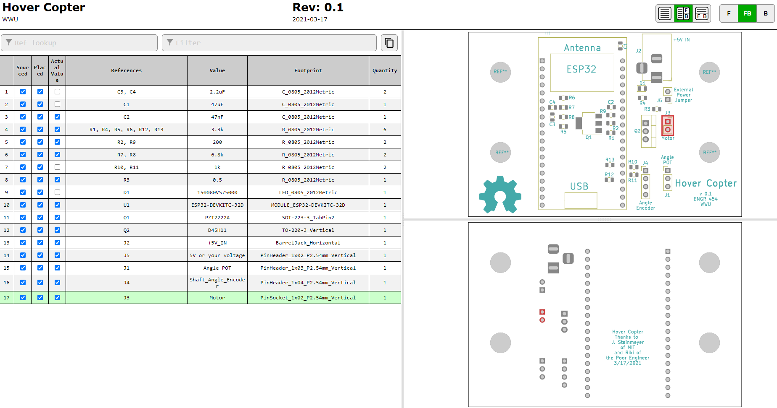

(See following pages for PCB pictures, last page for test)

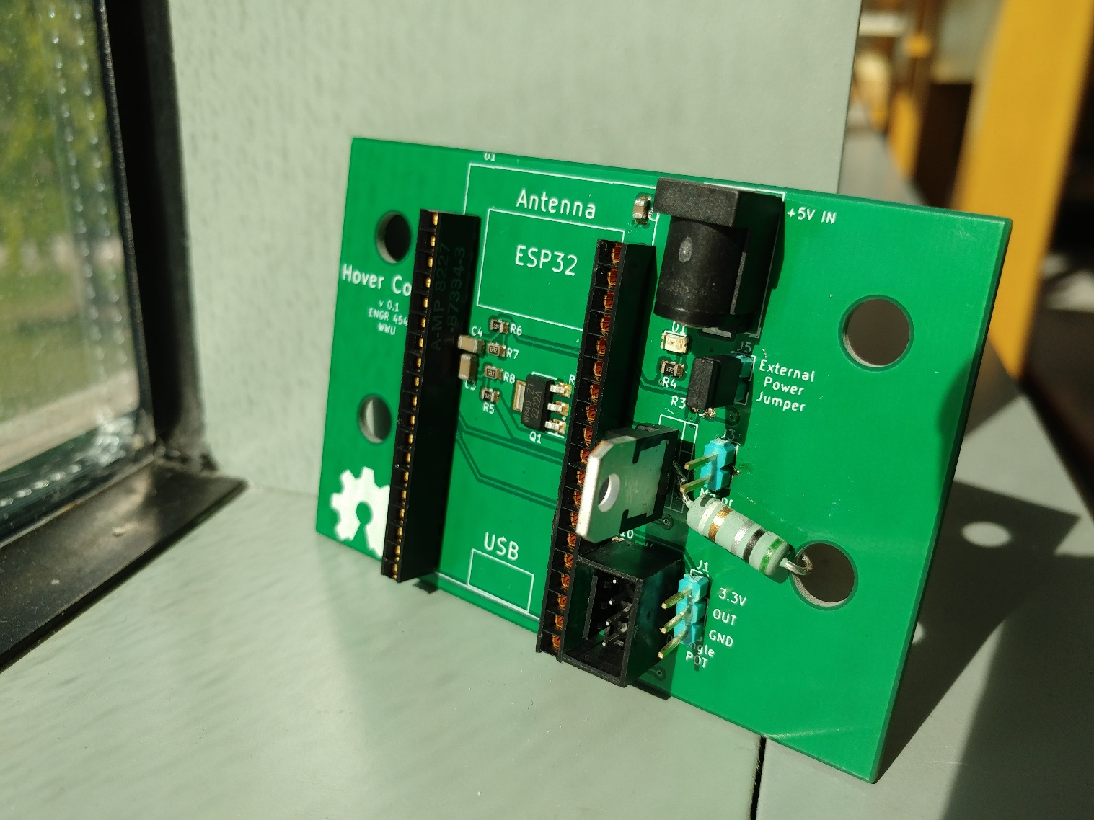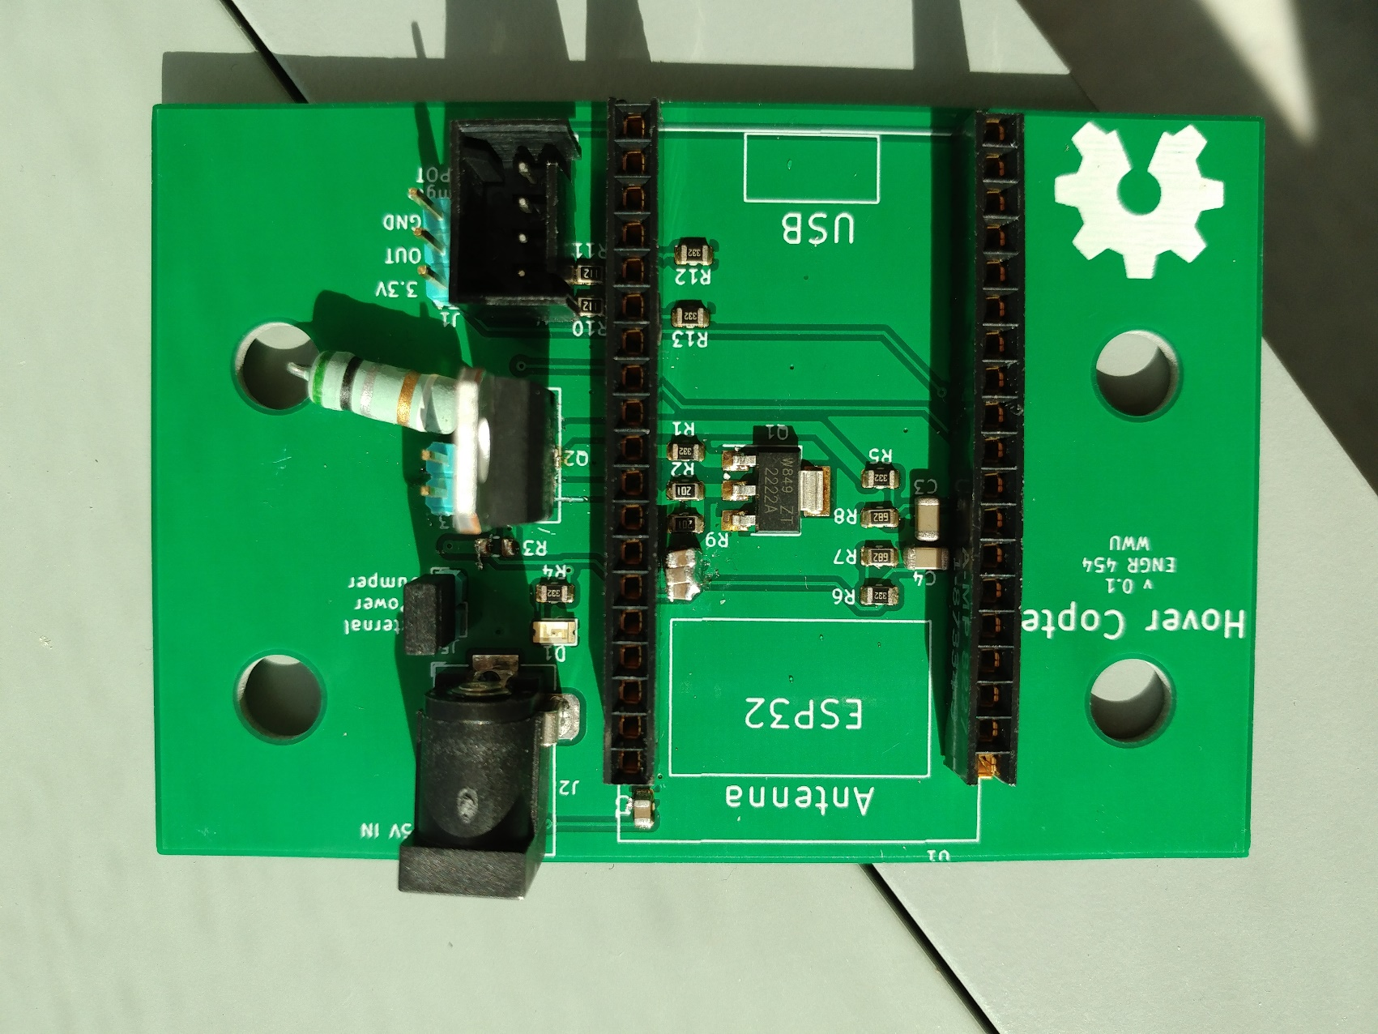

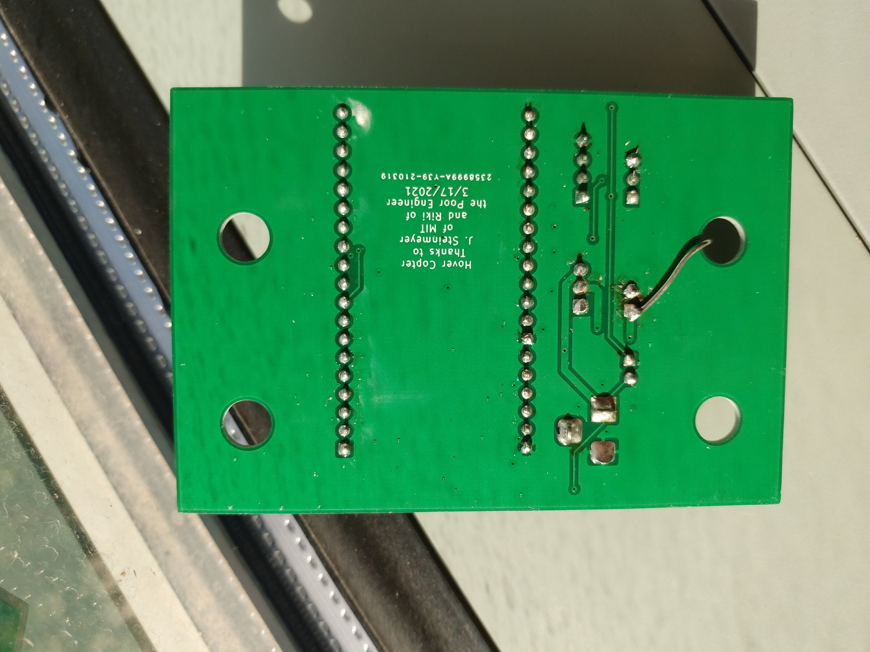

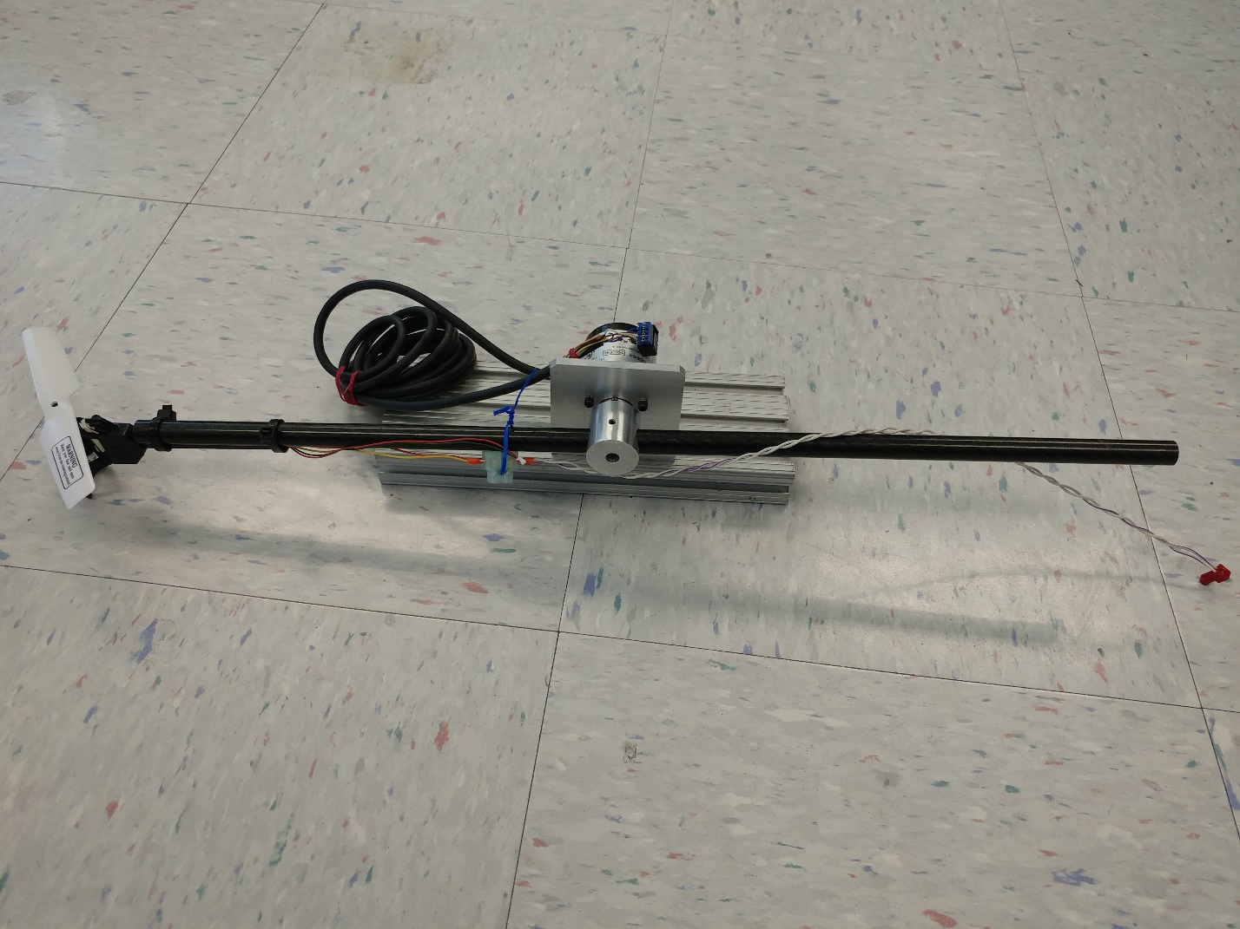

*Our mechanism will be the same/similar to this one, but the parts have not been machined yet. This is the one that has been built for us as an initial one and for an example to base our build on.

**Testing:**

We used a “Blinking LED” program to test switching the motor output on and off. We looked at the Motor pin and Pin 5 (see below picture) and their respective voltages make sense and line up well.

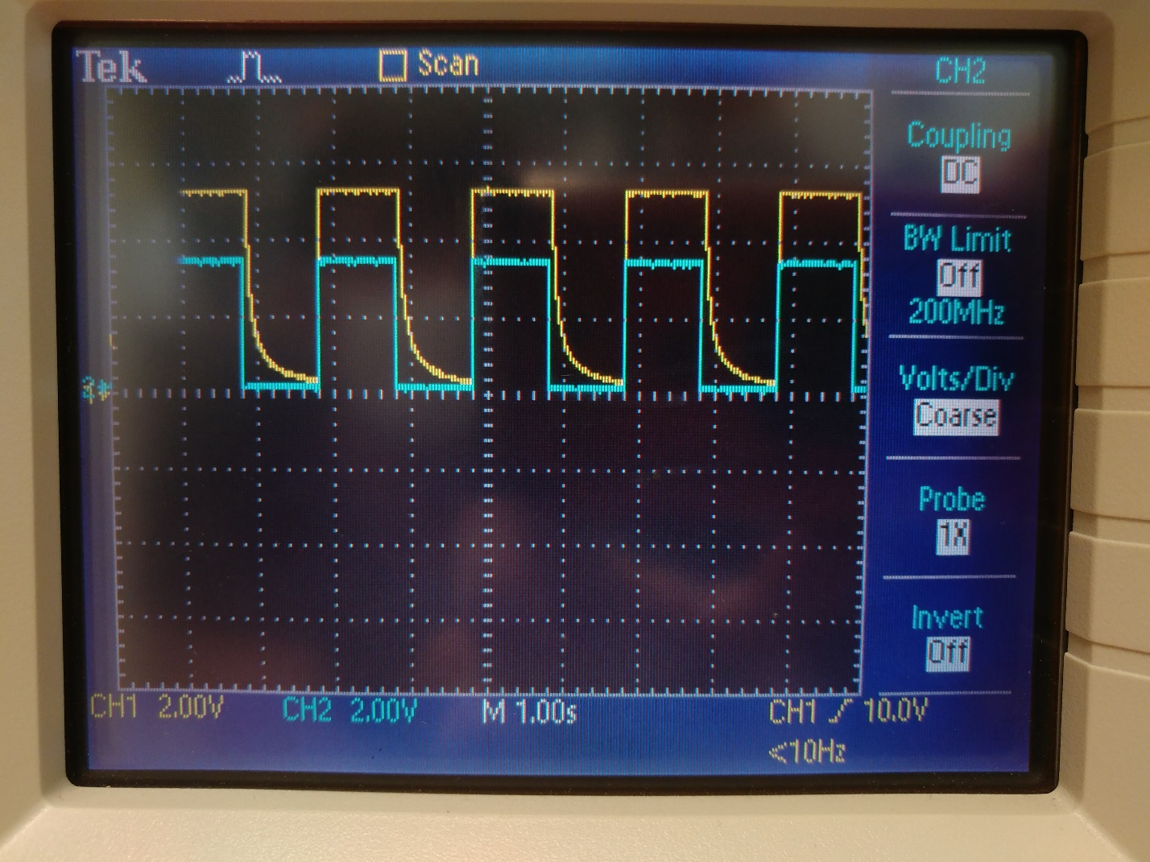

*Motor pin is CH1 and Pin 5 is CH2